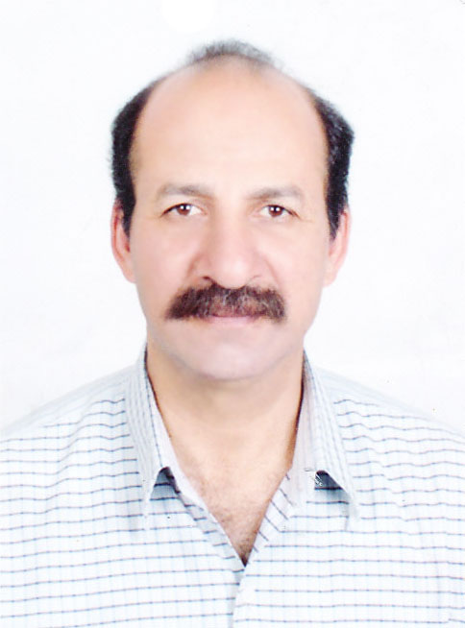


Name: Mansour Ibrahim Abd - elhady El- mansy

Surname : Mansour El- mansy .

Job : Dean of Specific Education Faculty–Assiut University & Prof. Sculpture Department of Art Education - Faculty of Specific Education - Assiut University .

Address: Egypt -Assiut University- Department of Art Education – Faculty of Specific Education.

Place of birth: Kalubeya – Egypt

Date of birth: 1 / 12 / 1956

Telephone home: 0020882296766

Mobile : 00201222447455

Fax : 0020882311535

Website : http://www.aun.edu.eg/fac_sedu/mansour_elmansy/index.htm

E-mail : el_mansyus@yahoo.com

* Master’s degree in art of sculpture – faculty of fine art – Helwan University 1989, the Discussion address:
” REALISM AND SYMPOLISM IN ENCIENT EGYPTION SCULPTURE “

* PHD in art of sculpture – faculty of fine arts – Helwan University 1993, the Discussion address “ REALISM AND SYMPOLISM IN MODERN SCULPTURE”

* Assistant Prof. In sculpture department faculty of fine arts Menia University, the Discussion address “ Situation Contemporary Egyptian Sculptor between modernity and Globalization “ 2001
* Professor at Art Education Department – faculty of Specific Education – Assiut university 2007

*- Exhibition of undergraduate students of faculty of fine arts Helwan University between 1975: 1980.
*- Exhibition of Youth and Sport Ministry 1978.
*- Exhibition of fine arts lovers association 1979.
*- General Exhibition culture ministry 1982 up till 2001.
*- Exhibition honoring contest the poet Hafez Ibarhem and the poet Ahmed Shawky 1984
* - Exhibition three artist in Cairo gallery 1984 .
*- Benali sofua Bulgaria of Youth 1985.
*-Youth contest under 35 year 1990.
*- Exhibition honoring the Egyptian Sculptor Mahoaud Mokhtar 1990.
*- Exhibition Fine Arts staff El_Menia University 1993.
*- Enlargement statue for Akhenaton (5 meters) with sculptures in garden of faculty of Fine Arts El_menia University 1994.
*- Enlargement state for Egyptian sculptor Gamal El_ Segeny 1995 in garden of faculty of Fine Arts El- menia University.
*- Enlargement state for Egyptian sculptor Ahmed Abd- elwhab 1995 in garden of faculty of Fine Arts El- menia University.
*- Exhibition Sculpture with group Sculptors Arab countries 1998 Amman – Jordan.
*- Individual exhibition Cairo gallery Feb. 1998.
*- Collective Exhibition (two artists) Cairo gallery July 1999
*-Individual Exhibition Cairo gallery December 1999
*- Collective Exhibition Assiut Culture gallery April 2000.
*- Collective Exhibition Grant gallery July 2000.
*- Small works contest at Culture Ministry 2000.
*- The fifty benali Port Said City 2001.
*- Individual Exhibition Cairo Gallery April 2001.
*- Collective Exhibition Grant gallery November 2001.
*- Symposium Sculpture with group Sculptures in Oamaru NZ 2002 lime stone .
*-Individual Exhibition Cairo gallery April 2002 bronze.
*- Symposium Sculpture in with group Sculptures Arab countries 2002 Amman – Jordan marble.
*- Egyptian Groups Exhibition with Egyptian opera house in Assiut University April 2002.

*- Prize of the general Exhibition 1982.
*- Acquisition Prize general Exhibition 1982.
*- Acquisition Prize for honoring contests the poet Hafez Ibrahem and Poet Ahmad Shawky 1984
*- The prize in youth Exhibition 1990.
*- Acquisition Prize international center for conferences Nasr City Cairo Egypt 1999.
*- The prize in the fifty Benali Port Said City 2001.

*- The statue the crossing boat symbol victory 6th October war 1973 Group of sculptors panorama October war in Cairo Egypt.
*- Relive Sculpture on front police club “ police Symbol “ (5.5 × 4 meter )
*- Statue of stainless steel (4meter× 1.5 × 1) city of St. Louis
*- Stone statue ( 150× 80× 80 C.M) Amman – Jordan.
*- Marble statue of the city south of France Tolz, 2006
*- The statue of peace symbol El_Helaly street 2007 in Assiut Governorate.
*- A limestone statue of Saudi Aramco height of (3 m × 1 m × 1 meter)
*- The Memorial of Asmaa Allah Al Hosna ( Al Azhar square ) at height 40 meter and width10 meter and entered the Guinness Records to be the largest model bears the names of Allah .
*- The Statue of limestone Aramco company ( Saudi Arabia ) .
*- Marble statue of the city Amman – Jordan 2002
*- A limestone statue of Newseland height of (180 c.m × 120 c.m × 100 c.m)
*- Design Oscar Universities Youth 6 th Week2003

*- Acquisition in the National Kingly Amman Jordan 1998.
*- Acquisition in Baladna gallery 1998
*- Acquisition in the National Kingly Amman Jordan 2002.
*- Acquisition modern art Museum Faculty of fine arts El_menia University.
*- Acquisition in Egypt and Pakistan with some people.
*- Acquisition modern art Museum Cairo .

*- Member of the judging committees Creative Forum Fourth Arab student
conference in Jordan from 17:19/7/2001 .
*- Member of the judging committees Creative Forum six conference in Human development – Libya from 13: 16/10/2003
*- Member of the judging committees Creative Forum 7th conference union Arabian universities in Morocco 2005 .
*- Member of the judging committees Creative Forum 9th conference2006 .
*- Member of the judging committees Creative Forum 10th conference in Jordan 2-5/9/2007 .
*- Decision of the International Committee in partnership with autumn salon France 2007
*- Decision of the Conference South dialogue - South (Faculty of Specific Education - Department of Art Education) 2007.
*- Decision of the Conference South dialogue - South (Faculty of Specific Education - Department of Art Education) 2010.
*- Decision of International Committee on the manufacture of paper from the remnants of the environment in partnership with Professor Kyoko Ibe April 2010 .
*- Member of the judging committees Creative Forum 14th conference in Alexandria – Egypt 2-6/10/2011 .

